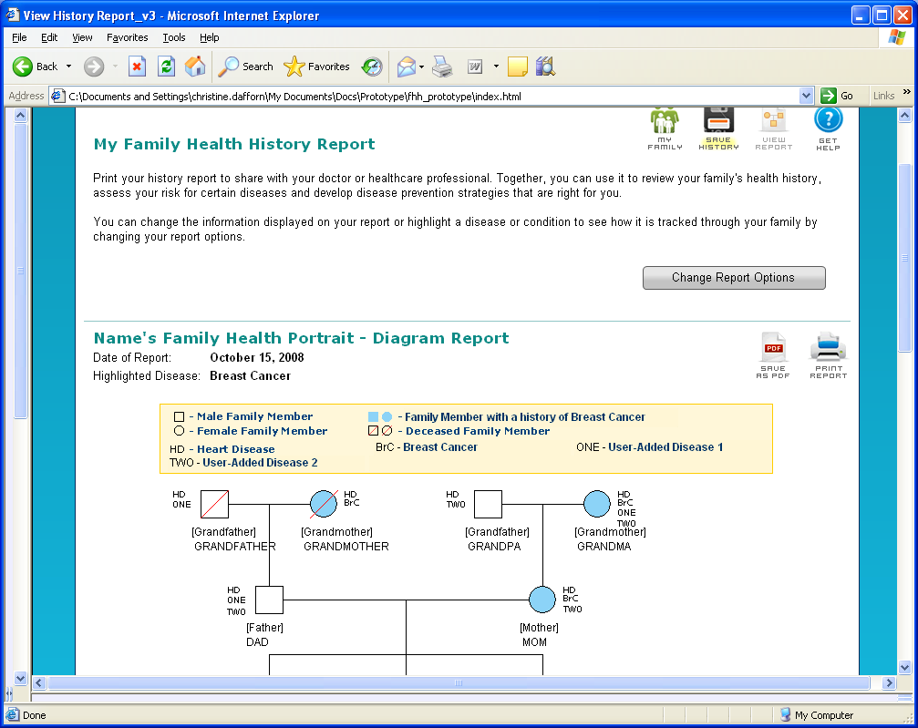

My Family Health History Report

You can print your history report to share with your healthcare worker. Talking with your health care worker about your family health history can help you stay healthy!

If you would like to change the information shown below, click on the “Change Report Options” button.

*Check to see if the name shows up as capitalized or regular*

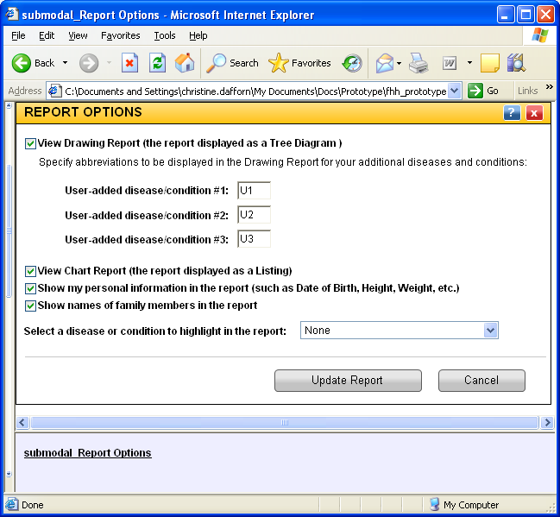

View Chart
You can view, save or print your Family Health History to share with your health care worker. They can assess your risk for certain diseases. They can then develop disease prevention strategies that are right for you. You can also share it with other family members. You can change what is shown in the report yourself.

Please click on the options below which you want in your report, and then click on the button to Update Report.

- View Drawing Report (the report displayed as a Tree Diagram)

Please enter abbreviations to be shown on your Family Chart for your additional diseases and conditions:

User-added disease/condition #1:
User-added disease/condition #2:
User-added disease/condition #3:

- View Chart Report (the report displayed as a Listing)
- Show my personal information in the report (such as Date of Birth, Height, or Weight)
- Show names of family members in the report
- Select a disease or condition to highlight in the report:

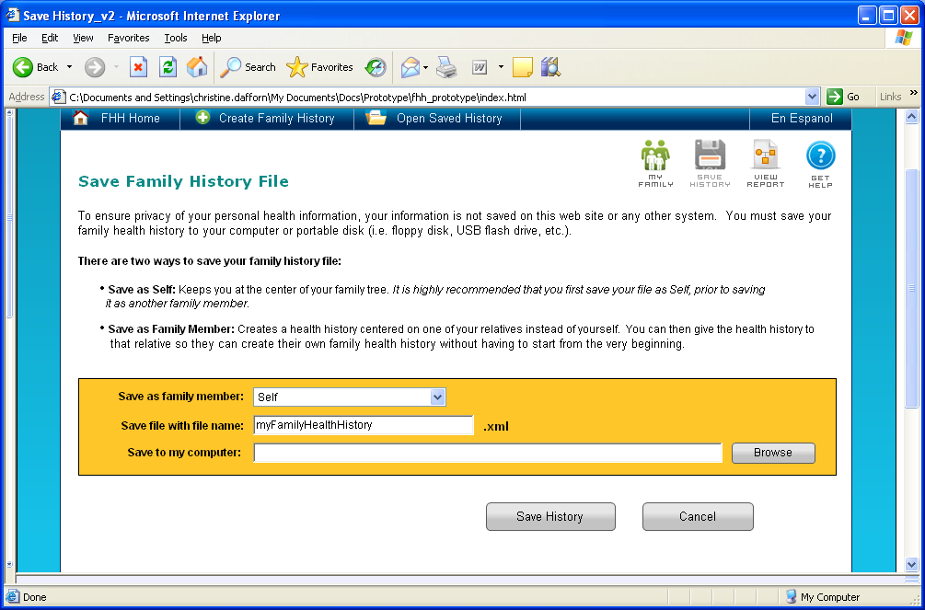

Save As a Different Family Member

You may make any relative be the center person of the Health History. You can then add relatives to create a new family health history without having to start from the very beginning.

You can see the changes in a family tree diagram by choosing the Preview button. The changes will not be made until you click on the Reindex button. This will replace the current Family Health History. Only family members that are a direct blood relative will display.

Your Family Health History is not saved on this web site or any other system. You must save your family health history to your computer or a portable disk (such as a floppy disk or USB flash drive).
Ashkenazi Jewish Info
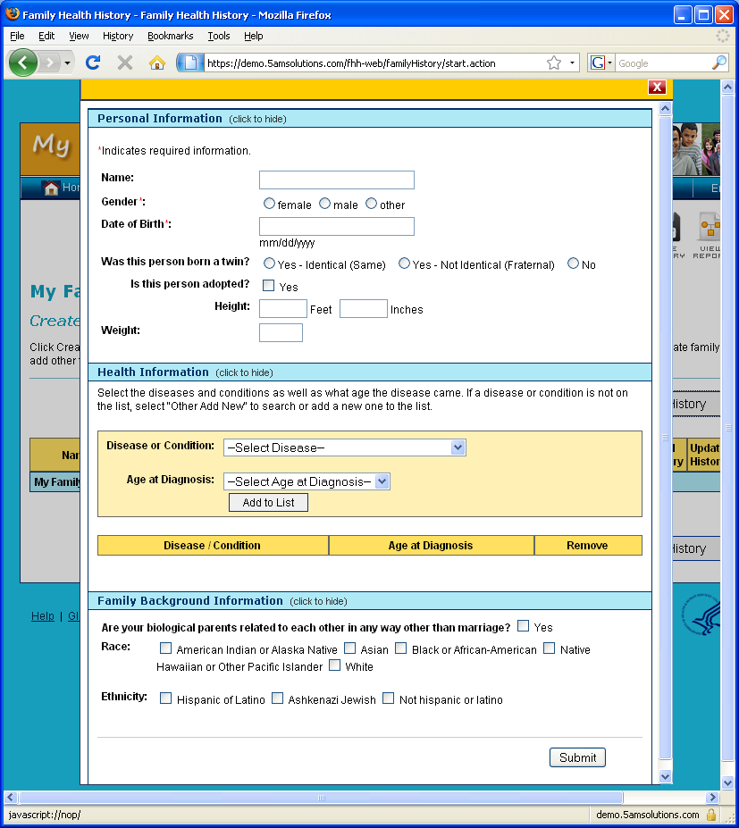

For the Ashkenazi Jewish heritage option, the following content will be offered:

There will be a link right next to Ashkenazi Jewish that reads “Why are we asking this question?”

That link, will lead to a page or other such pop-up with the following content:

“For certain conditions such as ovarian and breast cancer it is important to know if you are Ashkenazi Jewish for risk assessment purposes”

